[Title]

The New York City bus system serves over a million riders per day. Despite this, the system is plagued with delays and crawling speeds, partially due to illegally parked vehicles obstructing the buses’ path.

One of the methods employed by the MTA to combat this is Automated Camera Enforcement (ACE). Beginning with ABLE and expanding into ACE, MTA buses are able to ticket vehicles.

This sparked three questions we hope to address:

1. What is the recidivism rate and distribution of all ticketed vehicles?
2. How has the average mph on ACE routes changed compared to non-ACE routes, and how does Congestion Pricing factor into this?
3. Has ACE reduced accidents?

Scroll down for our analysis or press Explore in the top-right for an interactive map.

{Map is base map with ace, none ace, etc)

______________________________________________

[What is ACE?]

ACE is the MTA’s automated camera enforcement system. In mid-2024, the existing ABLE ticketing system was expanded into ACE. ABLE stood for Automated Bus Lane Enforcement and only ticketed a vehicle if they were blocking a bus lane or bus stop. ACE expanded on this to include double-parked and other illegally parked automobiles.

If two buses are more than five minutes apart record a vehicle engaging in illegal parking behavior, then they will receive a $50 ticket. Each subsequent ticket will raise the fine by $50 until it reaches $250, the cap.   
______________________________________________

{Transition to ticket heat map (still keep bus routes)}

[Ticketing Recidivism]

ACE violations are broken down into 7 categories:

1. Violation Issued
2. Exempt: Emergency Vehicle
3. Exempt: Small Commercial Vehicle
4. Exempt: Bus/Paratransit Service
5. Exempt: Other
6. Driver/Vehicle Info Missing (no ticket)
7. Technical Issue/Other (no ticket)

For the data analysis in this section, exempt categories will generally be grouped together.

______________________________________________

| Table 1: Basic ACE Data: Number of Unique Vehicles; Mean, Median, and Mode Number of Tickets Per Vehicle; and Total Tickets for Each Category | | | | | | | | | |
| --- | --- | --- | --- | --- | --- | --- | --- | --- | --- |
|  |  | |  | | |  | | | |
|  | **Violation Issued** | **Exempt - All** | **Exempt - Emergency Vehicle** | **Exempt - Commercial Under 20** | **Exempt - Bus/Paratransit** | **Exempt - Other** | **Driver/Vehicle Info Missing** | **Technical Issue/Other** |  |
| Number of Vehicles | 1024439.000 | 154124.000 | 25972.000 | 81460.000 | 30170.000 | 37230.000 | 99238.000 | 195873.000 |  |
| Mean | 2.258 | 5.650 | 13.277 | 3.618 | 7.731 | 2.403 | 2.761 | 1.535 |  |
| Median | 1.000 | 1.000 | 2.000 | 1.000 | 2.000 | 1.000 | 1.000 | 1.000 |  |
| Mode | 1.000 | 1.000 | 1.000 | 1.000 | 1.000 | 1.000 | 1.000 | 1.000 |  |
| Total Tickets | 2312878.000 | 870810.000 | 286253.000 | 257374.000 | 190192.000 | 136991.000 | 273968.000 | 320912.000 |  |
| Source: MTA Bus Automated Camera Enforcement – [data.ny.gov](http://data.ny.gov/) | | | | | | | | | |

The chart above shows the number of unique vehicle IDs in each section and the mean, median, and mode number of tickets a vehicle typically receives. The table also shows the total number of tickets in each category.

For example, over a million unique cars were issued a violation and over 2.3 million tickets were issued. However, the median and mode is 1, indicating a problem facing other automated enforcement: high recidivism among a small group of people (super illegal parkers). This problem is also seen in speed camera enforcement (super speeders).

The median number of exempt tickets for emergency vehicles and Paratransit is 2, and their averages are significantly higher than other categories. Despite a significantly smaller number of unique vehicles, they are roughly equal to the two other exempt categories in the number of exempt tickets. Other solutions besides stricter enforcement would be needed to solve this problem.

______________________________________________

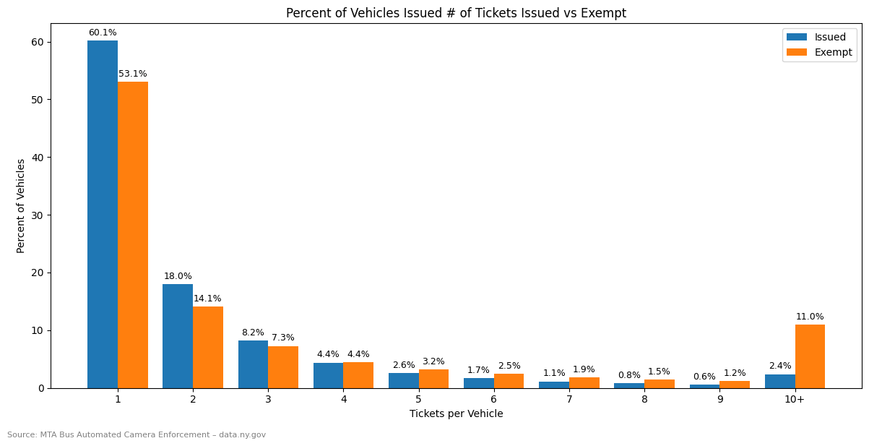

The above chart is another way to visualize this problem. Out of all one million vehicles that received a ticket, 60.1% received only one. However, 2.4% of all unique vehicle IDs were issued more than 10 tickets.

This problem is more acute for exempt vehicles. Over 11% of all unique vehicles committed over 10 violations. Based on our prior table, this problem is likely concentrated among emergency vehicles, buses, and Paratransit.

______________________________________________

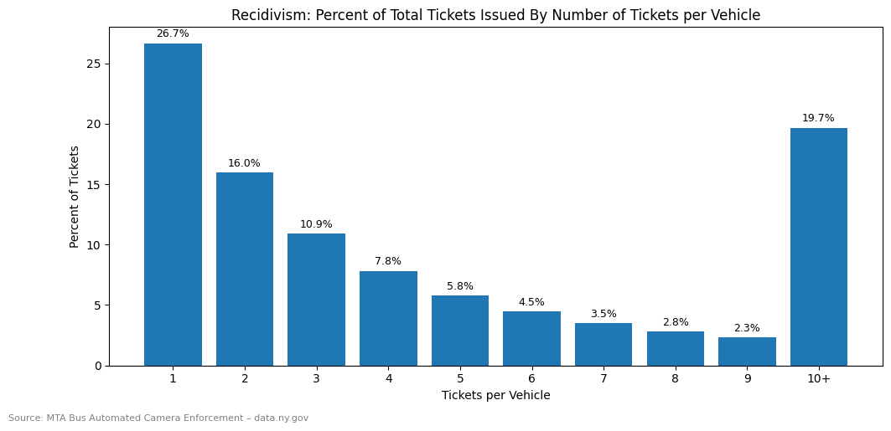

This chart shows what percentage of violations/tickets issued to people in each of the 10 categories. Despite only 2.4% of vehicles receiving more than 10 tickets, they compose 19.7% of all tickets received.

Almost half of all tickets issued were to vehicles with 4 tickets or more despite only 13.6% of vehicles being in the same category.

______________________________________________

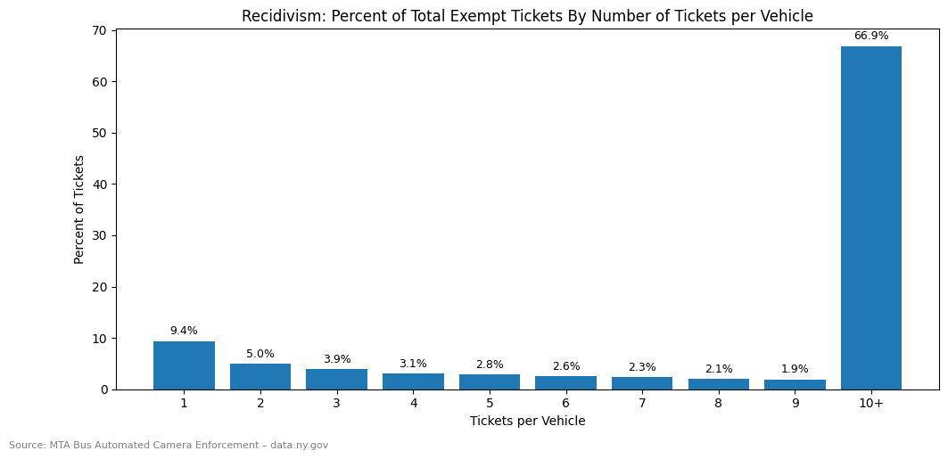

This story holds even more true when looking at exempt vehicles.

66.9% of all exempt violations were given to vehicles with 10 or more prior instances.

We believe this indicates structural issues in the city regarding space allocation as Paratransit, commercial, and emegency are all forced into violating parking law.

______________________________________________

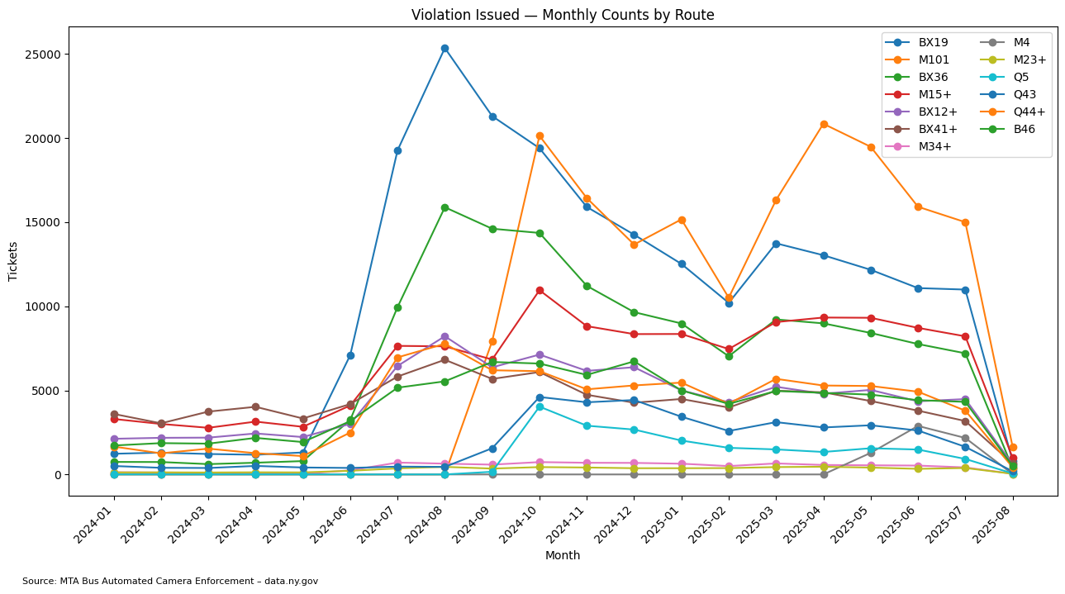

We will ignore August 2025 as the data was incomplete.

This chart shows the number of tickets issued each month on select bus routes. The top and bottom routes had the largest number of tickets in the whole dataset.

All routes follow a similar pattern: a spike in tickets between May and September of 2024, likely from the switch from ABLE to ACE and the initial expansion of the program. A subsequent spike is seen in March and April of 2025, coinciding with another expansion ACE.

The BX19 and M101 have, by far, the most number of tickets.

______________________________________________

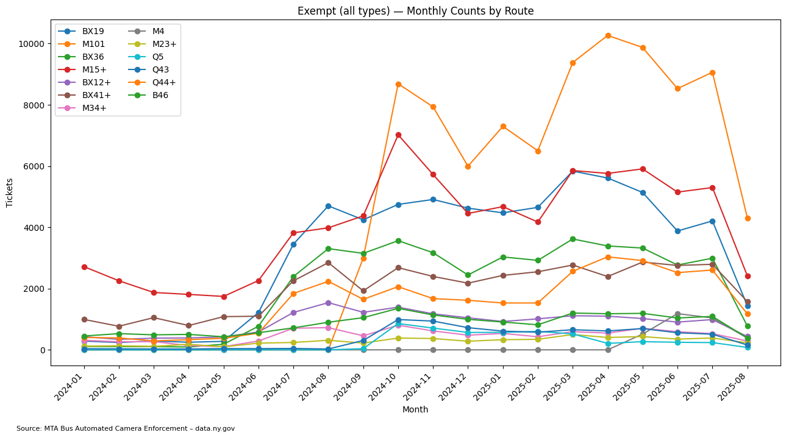

The exempt data is similar in its spikes but not in the trough. This is likely because they are (rightfully) not punished for violations and further confirms a structural issue.

______________________________________________

[Solutions]

These results are similar to speed camera data. There is a small portion of “super speeders” that contribute a disproportionate number of violations. We can look to proposed speeding solutions and apply them here.

Potential solutions require changes to the fine structure, passage of state laws, and partnership with the DOT.

We propose:

1. Harsher Fines

* The 5th fine is the same value as the 105th fine. The $250 cap should be raised to further disincentivize illegal behavior.
* MTA should partner with NYPD to further crack down on unpaid tickets.

1. Vehicle Modification Through State Law

* Currently, a “super speeder” bill has been proposed in the state legislature that would impose harsher penalties on frequent offenders. A similar bill could be adopted.

1. Street Redesigns

* MTA should further it's partnership with DOT by dedicating more street space along highly fined routes (BX19, M101, BX36) to the exempt usages.
* A certain number of parking spots along commercial corridors should be dedicated commercial loading zones.
* Emergency vehicle only lanes should be created on certain wide streets, especially where respond times are long and potentially life threatening. This removes vehicles from conflicting with buses.

______________________________________________

[Impact on Speed]

To assess the impact of ACE, we examined speed changes along ACE bus routes and compared them to several benchmarks: ACE routes before implementation, non-ACE routes to test for system-wide effects, and routes within the Central Business District (CBD) subject to congestion pricing to capture their combined influence. Our analysis shows that both congestion pricing and ACE improve bus speeds, and their benefits are cumulative. However, congestion pricing exerts a stronger effect on overall bus performance.

______________________________________________

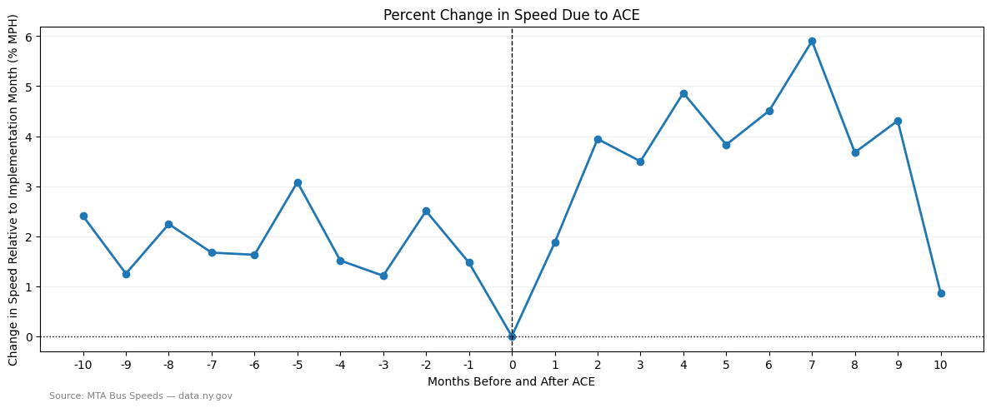

This time-series chart shows the percent change in speed across the aggregate of all 43 ACE routes from before ACE was implemented on the route to after. The middle 0 point is when ACE was implemented. The line dips just before implementation but quickly climbs afterward, averaging around a 4-5% gain in speed. This implies ACE is correlated with faster bus speeds that sustain for almost a year. The drop off at the 10-month mark is likely due to data and coding-related issues rather than sharp speed declines. However, we still need to compare it to non-ACE routes.

______________________________________________

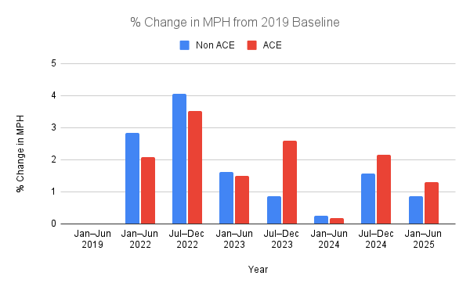

This grouped bar chart tracks changes in average bus speeds relative to a 2019 (pre-COVID) baseline for ACE and non-ACE routes. The large gains in 2022 are likely a temporary artifact of reduced traffic during the pandemic, as overall activity in New York City was still below pre-2019 levels. By late 2023, late 2024, and into 2025, a clearer picture emerges: ACE routes maintained higher speeds than non-ACE routes, despite ACE corridors typically having higher traffic of all modes. This suggests that ACE positively impacts speeds.

______________________________________________

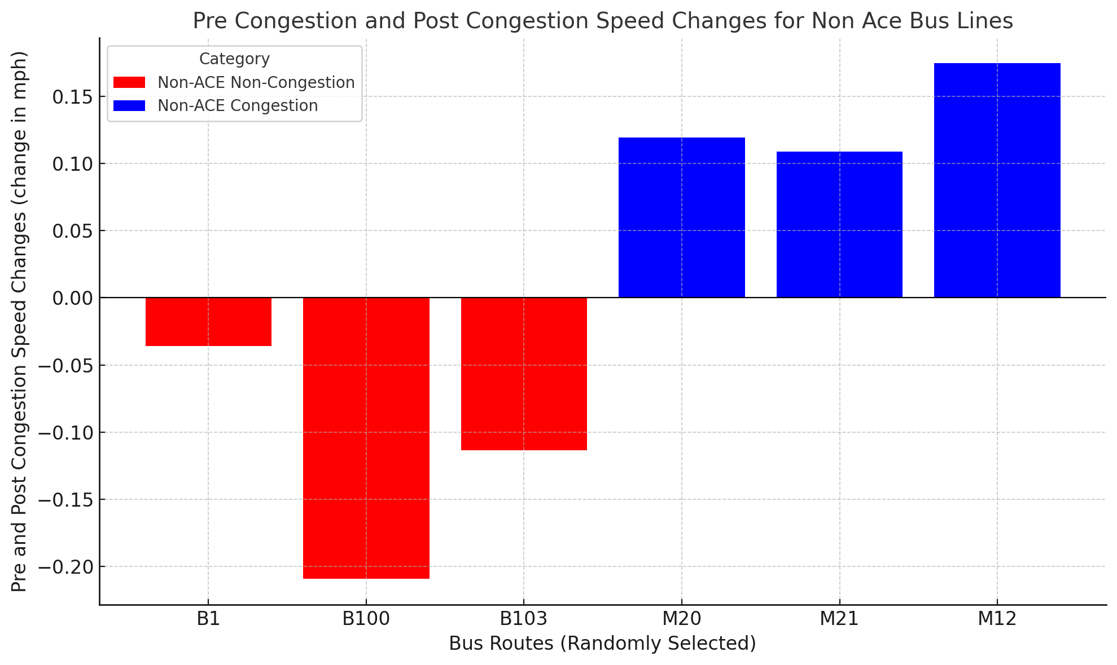

To deepen the analysis of ACE and congestion pricing, we randomly selected six non-ACE bus routes: three within the congestion zone and three in Brooklyn, outside the zone. The results reveal a clear divide. All three congestion-zone routes show notable speed gains, with the M12 improving by more than 0.15 mph. By contrast, all three Brooklyn routes experienced considerable speed declines, echoing trends observed in earlier charts. This pattern suggests that congestion pricing effectively reduced traffic volumes in the CBD, leading to faster bus travel.

Importantly, these findings do not imply that traffic was simply displaced elsewhere. The B1 and B100 corridors are located far from the CBD and do not directly intersect with it, making it unlikely that congestion shifted to those areas. Instead, the data points toward congestion pricing having a localized effect: easing traffic within the CBD without producing offsetting increases in peripheral corridors.

______________________________________________

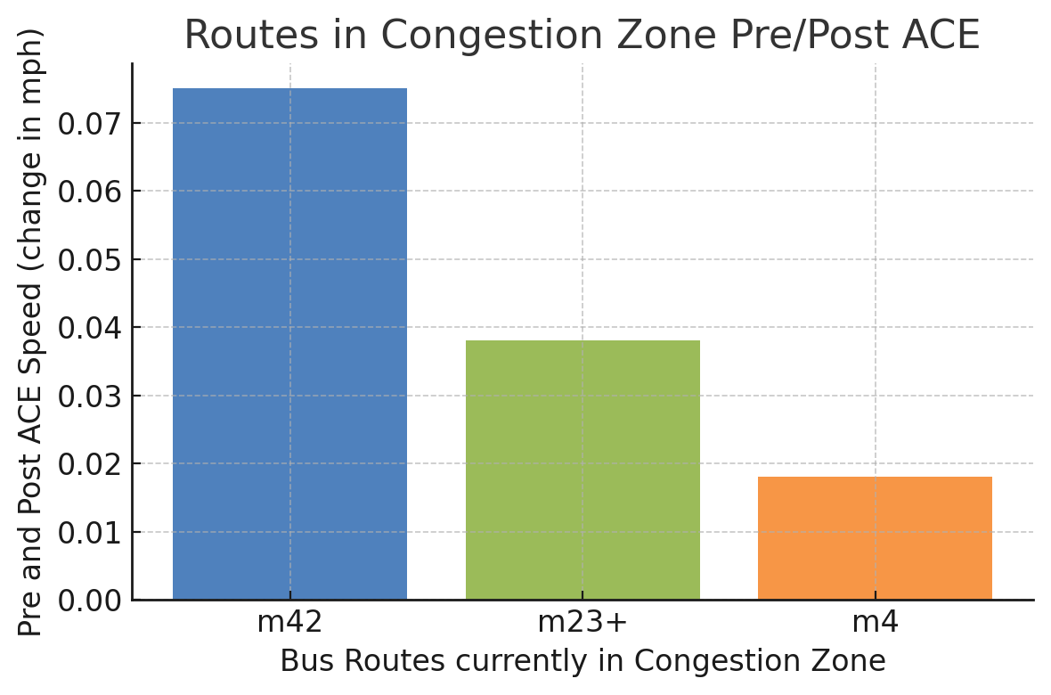

To further examine the effects on bus services, we selected three bus routes that were part of the CBD but didn’t have ACE until later on in the year. A key takeaway is the increase in speed gains, with the M42 showing an improvement of more than 0.07 mph.

______________________________________________

To conclude, both congestion pricing and ACE had positive impacts on speed. Despite the smaller impact of ACE, 5% still makes a considerable impact. To further improve buses, the MTA should consider expanding the ACE program, and the state government should consider expanding congestion pricing to heavily delayed areas such as Downtown Brooklyn.

______________________________________________

[Did ACE reduce accidents?]

{Map now shifts to accident heat map with overlay of bus routes}

We analyzed the impact of ACE on car accidents and fatalities.

We hypothsized that ACE expansion would have a noticeable reduction in the number of car crashes and fatalities.

Red light and speeding cameras, other forms of automated enforcement, have been proven to reduce crashes. We hypothsized a similar effect from ACE.

______________________________________________

[Post two charts or data points showing it did not]

______________________________________________

Our data shows ACE has a minimal, if any, impact on accidents.

Illegal parking does not seem to have the dangerous effect on roads that speeding or red light violations do, which is understandable. Speeding inherently makes crashes more dangerous and red light violations inherently raise the chance of a crash.

Illegal parking makes roads less efficient, potentially slowing down speeds.

However, our analysis is incomplete. Perhaps as all forms of traffic recovered from COVID accidents would've risen if ACE was not in place. Further research is needed.

______________________________________________

[Conclusion]